**Advanced software engineering**

**I-Explore (4th increment)**

Vishnu Praveen gude

Ravi sankar are

Venkata naveen pandala

Ayyappa kumar neerukonda

Description:

1. We designed nearby housing feature which provides housing information near the university for the user.
2. We designed student life feature which provides user about student life information.
3. We developed design of web application.
4. We developed contact us feature which provides contact information of different departments to the user.
5. We also developed tend to admissions feature which specifies the user about their chances of getting admission into the university or not.

**SOURCE CODE:**

**Admissions**

using System;

using System.Collections;

using System.Configuration;

using System.Data;

using System.Linq;

using System.Web;

using System.Web.Security;

using System.Web.UI;

using System.Web.UI.HtmlControls;

using System.Web.UI.WebControls;

using System.Web.UI.WebControls.WebParts;

using System.Xml.Linq;

using System.Data.SqlClient;

using System.Globalization;

using System.Collections.Generic;

using System.Net;

using System.Net.Mail;

namespace WebApplication12

{

public partial class WebForm7 : System.Web.UI.Page

{

string Connstr = ConfigurationManager.ConnectionStrings["ConnectionString"].ConnectionString;

string str, uname, pwd;

SqlCommand com;

SqlDataAdapter sqlda;

DataTable dt;

int RowCount;

protected void Page_Load(object sender, EventArgs e)

{

}

protected void Button2_Click1(object sender, EventArgs e)

{

int error = 0;

if (fname.Text == string.Empty || lname.Text == string.Empty || emailid.Text == string.Empty || gre.Text == string.Empty || toefl.Text == string.Empty || ielts.Text == string.Empty || ug.Text == string.Empty || gpa.Text == string.Empty || graduate.Text == string.Empty)

{

error = 1;

}

if (error == 0)

{

if (Convert.ToInt32(gre.Text) >= 290 && Convert.ToInt32(gpa.Text) >= 3 && (Convert.ToInt32(toefl.Text)>=80 || Convert.ToInt32(ielts.Text)>=6))

{

var chars = "ABCDEFGHIJKLMNOPQRSTUVWXYZ0123456789";

var random = new Random();

var result = new string(

Enumerable.Repeat(chars, 8)

.Select(s => s[random.Next(s.Length)])

.ToArray());

SqlConnection con = new SqlConnection(Connstr);

com = new SqlCommand();

com.Connection = con;

com.CommandType = CommandType.Text;

com.CommandText = "Insert into Table1 values(@fname,@lname,@emailid,@gre,@toefl,@ielts,@ug,@gpa,@workexp,@graduate,@rnum)";

com.Parameters.Clear();

com.Parameters.AddWithValue("@fname", fname.Text);

com.Parameters.AddWithValue("@lname", lname.Text);

com.Parameters.AddWithValue("@emailid", emailid.Text);

com.Parameters.AddWithValue("@gre", gre.Text);

com.Parameters.AddWithValue("@toefl", toefl.Text);

com.Parameters.AddWithValue("@ielts", ielts.Text);

com.Parameters.AddWithValue("@ug", ug.Text);

com.Parameters.AddWithValue("@gpa", gpa.Text);

com.Parameters.AddWithValue("@workexp", workexp.Text);

com.Parameters.AddWithValue("@graduate", graduate.Text);

com.Parameters.AddWithValue("@rnum", result);

if (con.State == ConnectionState.Closed)

con.Open();

com.ExecuteNonQuery();

con.Close();

label1.Text = "<font color=green>Congratulations !!! Your chance of getting admission is very high.Apply as soon as possible<font>";

var fromAddress = new MailAddress("gvishnupraveen@gmail.com", "Vishnu Gude");

var toAddress = new MailAddress("gvishnu146@gmail.com", "vishnu gude");

const string fromPassword = "Vishnu0425gmail";

const string subject = "New Student Qualified";

string body = "ID :"+result;

var smtp = new SmtpClient

{

Host = "smtp.gmail.com",

Port = 587,

EnableSsl = true,

DeliveryMethod = SmtpDeliveryMethod.Network,

UseDefaultCredentials = false,

Credentials = new NetworkCredential(fromAddress.Address, fromPassword)

};

using (var message = new MailMessage(fromAddress, toAddress)

{

Subject = subject,

Body = body

})

{

smtp.Send(message);

}

}

else

{

label1.Text = "Sorry You didnt met University requirements....Your chance of getting admission is very Low!!!";

}

}

else

{

label1.Text = "<font color=red>please check all fields carefully and enter valid data</font>";

}

}

}

}

**Contact page**

<%@ Page Title="" Language="C#" MasterPageFile="~/innerpages.Master" AutoEventWireup="true" CodeBehind="life.aspx.cs" Inherits="WebApplication12.WebForm8" %>

<asp:Content ID="Content1" ContentPlaceHolderID="head" runat="server">

</asp:Content>

<asp:Content ID="Content2" ContentPlaceHolderID="ContentPlaceHolder1" runat="server">

<div id="title">

<h1 class="inner title-2">Contact Us

<ul class="breadcrumb-inner">

<li> <a href="main.aspx">Home</a></li>

<li> <a href="contact.aspx">Contact us</a></li>

</ul>

</h1>

</div>

<div class="inner">

<!-- Content Inner -->

<div class="content-inner">

<!-- Content Center -->

<div class="content-center">

<div class="body">

<div class="clear"></div>

<div class="heading-l">

<h2>University Of Missouri Kansas City</h2>

</div>

<div class="post-box box-1">

<p><strong>Contact us</p>

<br />

<div>

<table>

<p>Chancellor Address</p>

<tr>

<td>Physical Location:

Office of the Chancellor

301 Administrative Center

5115 Oak Street

Kansas City, MO 64112

</td>

<td>

Mailing Address:

5100 Rockhill Road

301 Administrative Center

Kansas City, MO 64110-2499

</td>

</tr>

</table>

<table>

<tr>

<td>

Phone:

816-235-1101</td></tr></table>

<table>

<p> International Student Affairs Office (ISAO)</p>

<tr>

<td>

Mailing Address:

International Student Affairs,

Student Success Center,

UMKC, 5000 Holmes Street,

Kansas City, MO 64110-2499</td>

<td>

Office Location:

International Student Affairs,

Student Success Center,

5000 Holmes Street, G-04

Kansas City, MO 64110</td>

</tr>

</table>

<table>

<tr>

<td>

Phone: 816-235-1113

</td></tr>

</table>

<table>

<P>School of Computing and Engineering

</P>

<tr>

546 Robert H. Flarsheim Hall

5110 Rockhill Road

Kansas City, MO 64110-2499

Phone: 816-235-1193</tr>

</table>

</div>

</div>

</div>

</div>

<div class="content-right">

<div id="about-us-navigation" class="box-1">

<div class="">

<ul>

</ul>

</div>

</div>

</div>

<!-- /Content Right -->

<div class="clear"></div>

<!-- Clear Line -->

</div>

<!-- /Content Inner -->

</div>

</asp:Content>

**Student life**

<%@ Page Title="" Language="C#" MasterPageFile="~/innerpages.Master" AutoEventWireup="true" CodeBehind="life.aspx.cs" Inherits="WebApplication12.WebForm8" %>

<asp:Content ID="Content1" ContentPlaceHolderID="head" runat="server">

</asp:Content>

<asp:Content ID="Content2" ContentPlaceHolderID="ContentPlaceHolder1" runat="server">

<div id="title">

<h1 class="inner title-2">Student Life

<ul class="breadcrumb-inner">

<li> <a href="main.aspx">Home</a></li>

<li> <a href="life.aspx">Student Life</a></li>

</ul>

</h1>

</div>

<div class="inner">

<!-- Content Inner -->

<div class="content-inner">

<!-- Content Center -->

<div class="content-center">

<div class="body">

<div class="clear"></div>

<div class="heading-l">

<h2>University Of Missouri Kansas City</h2>

</div>

<div class="post-box box-1">

</div>

<p><strong>Student Life</strong></p>

<br />

<div>

<table>

<p>Housing</p>

<tr>

<td>Single Bedroom:</td>

<td>550-650$ </td>

<td>Double Bedroom :</td>

<td>750-850$</td>

<td>Total Cost of living per month per person is 300-350$</td>

</tr>

</table>

<table>

<p>Grocery</p>

<tr>

<td>walmart

</td>

</tr>

<tr>

<td>Cosco

</td>

</tr>

<tr>

<td>City Market

</td>

</tr></table>

<table>

<p>Shopping Malls</p>

<tr>

<td>The Country club plaza

</td>

</tr>

<tr>

<td>Oak park mall

</td>

</tr>

<tr>

<td>Town center plaza

</td>

</tr>

</table>

</div>

</div>

</div>

<div class="content-right">

<div id="about-us-navigation" class="box-1">

<div class="">

<ul>

<li class="active"><a href="life.aspx">Student Life</a></li>

</ul>

</div>

</div>

</div>

<!-- /Content Right -->

<div class="clear"></div>

<!-- Clear Line -->

</div>

<!-- /Content Inner -->

</div>

</asp:Content>

**Housing**

using System;

using System.Collections.Generic;

using System.Linq;

using System.Web;

using System.Web.UI;

using System.Web.UI.WebControls;

using Newtonsoft.Json;

namespace WebApplication12

{

public partial class WebForm4 : System.Web.UI.Page

{

protected void Page_Load(object sender, EventArgs e)

{

string str="";

string imgs = "";

var url = "http://www.rentmetrics.com/api/v1/homes.json?address=64110&bedrooms=4&api_token=TEST&offset=0&limit=5&include_images=true";

var json = new System.Net.WebClient().DownloadString(url);

RootObject4 m = JsonConvert.DeserializeObject<RootObject4>(json);

cells.InnerHtml = "";

for (int i = 0; i < 5; i++)

{

try

{

for (int j = 0; j <= 3; j++)

{

str = str+", "+m.collection[i].features[j].ToString();

}

}

catch

{

str = "..";

}

try

{

imgs = m.collection[i].images[0].url.ToString();

}

catch

{

imgs = "";

}

cells.InnerHtml = cells.InnerHtml + "<div class='field-container' odd box-1'><div class='cells-job-thumb'>";

cells.InnerHtml = cells.InnerHtml + "</div><div class='header-fields'><div class='title-company'>";

cells.InnerHtml = cells.InnerHtml + "<div class='title'><a id='end' value='" + m.collection[i].address+ ", "+m.collection[i].neighborhood+", "+m.collection[i].city+"'>"+m.collection[i].address+ ", "+m.collection[i].neighborhood+", "+m.collection[i].city+"</a></div>";

cells.InnerHtml = cells.InnerHtml + "<div class='company'>" + m.collection[i].zip_code + ", " + m.collection[i].state + "</div></div></div>";

cells.InnerHtml = cells.InnerHtml + "<div class='body-field'><div class='teaser'><b>features:<b><a> " + str + "</a><ul class='candidate-meta meta-fields'><li class='pull-left'>Year Built:<span>" + m.collection[i].year_built + "</span></li><li class='pull-center'>Bed Rooms : <span>" + m.collection[i].bedrooms + "</span></li><li class='pull-right'>Rent: <span>$" + m.collection[i].rent + "</span></li></ul><ul class='candidate-meta meta-fields'><li class='pull-left'>Rent Date : <span>" + m.collection[i].rent_posted_date + "</span></li><li class='pull-right'>Distance: <span>" + m.collection[i].distance_mi + "mi</span></li></ul></div>";

cells.InnerHtml = cells.InnerHtml + "<img src='" + imgs + "' alt='images'/><div class='block-fields'><div class='block skills'><div class='block-content'><div class='clear'></div></div></div>";

cells.InnerHtml = cells.InnerHtml + "<div class='block'><div class='clear'></div></div></div></div></div> ";

}

}

public class Imgs

{

public string url { get; set; }

public string width { get; set; }

public string height { get; set; }

}

public class Collection

{

public string address { get; set; }

public string neighborhood { get; set; }

public string city { get; set; }

public string zip_code { get; set; }

public string state { get; set; }

public double latitude { get; set; }

public double longitude { get; set; }

public double distance_mi { get; set; }

public List<object> features { get; set; }

public double sq_ft_lot { get; set; }

public double year_built { get; set; }

public double bedrooms { get; set; }

public int full_bathrooms { get; set; }

public int partial_bathrooms { get; set; }

public double sq_ft { get; set; }

public string rent_posted_date { get; set; }

public double rent { get; set; }

public double rent_per_sq_ft { get; set; }

public double eff_rent { get; set; }

public double? eff_rent_per_sq_ft { get; set; }

public object concession_type { get; set; }

public object concession_value { get; set; }

public List<Imgs> images { get; set; }

}

public class RootObject4

{

public List<Collection> collection { get; set; }

public int total { get; set; }

public int offset { get; set; }

public int limit { get; set; }

}

}

}

Webpage of application:

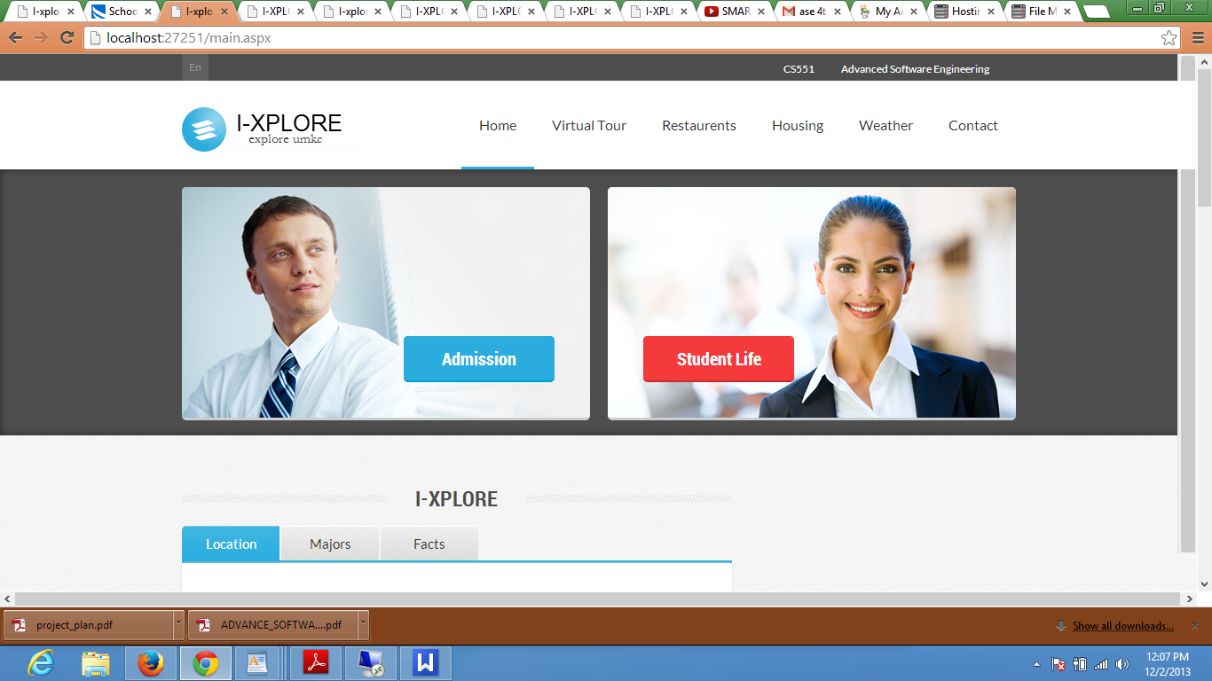

Majors is a feature in web application which shows different majors in the university.

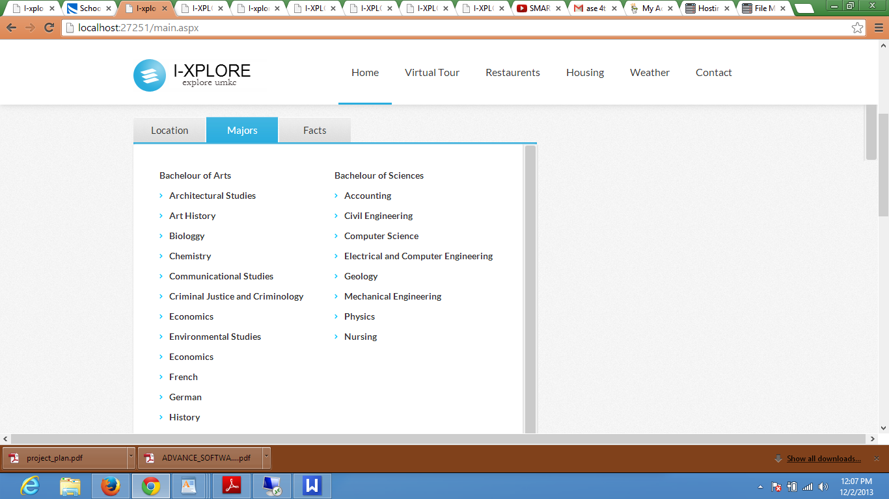

Student Life Feature option in web application.

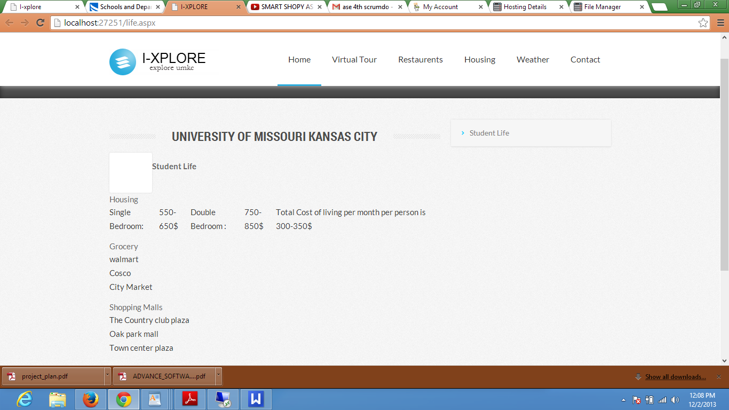

Sign Up form in web application, which is used by registers to register.

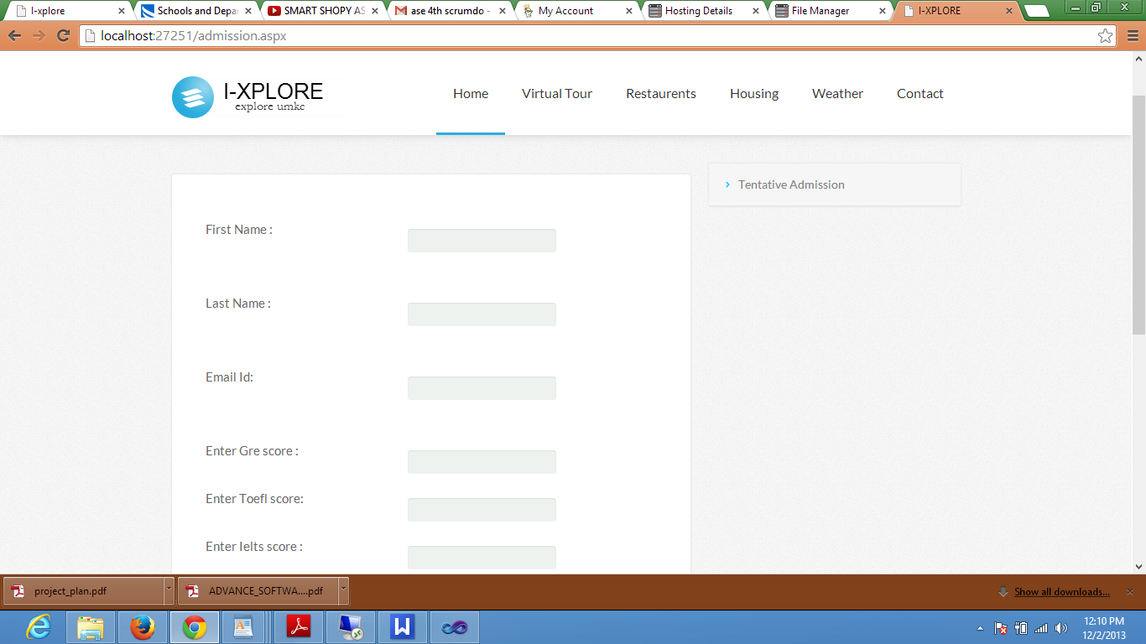

After providing required information it gives confirmation of sign up.

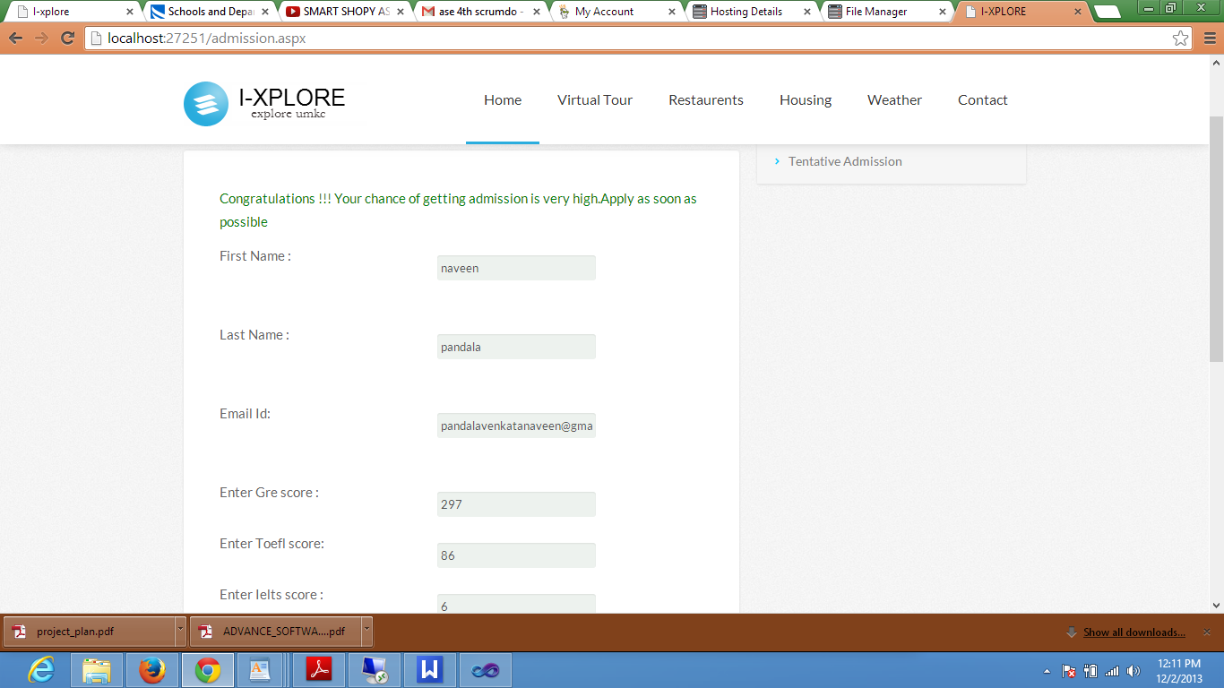

Tentative admissions is also a feature which provides the user about the information whether they get admission or not.

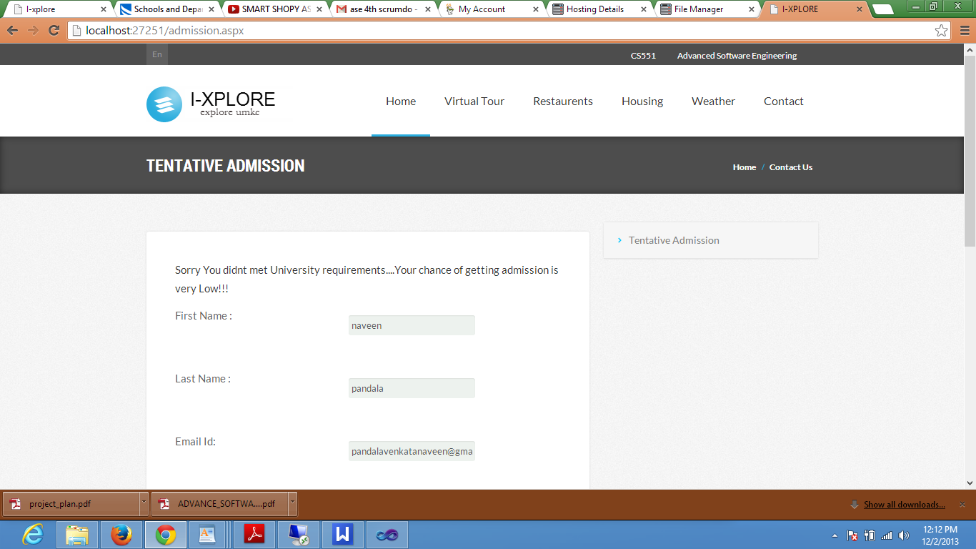

Housing feature in Web application.

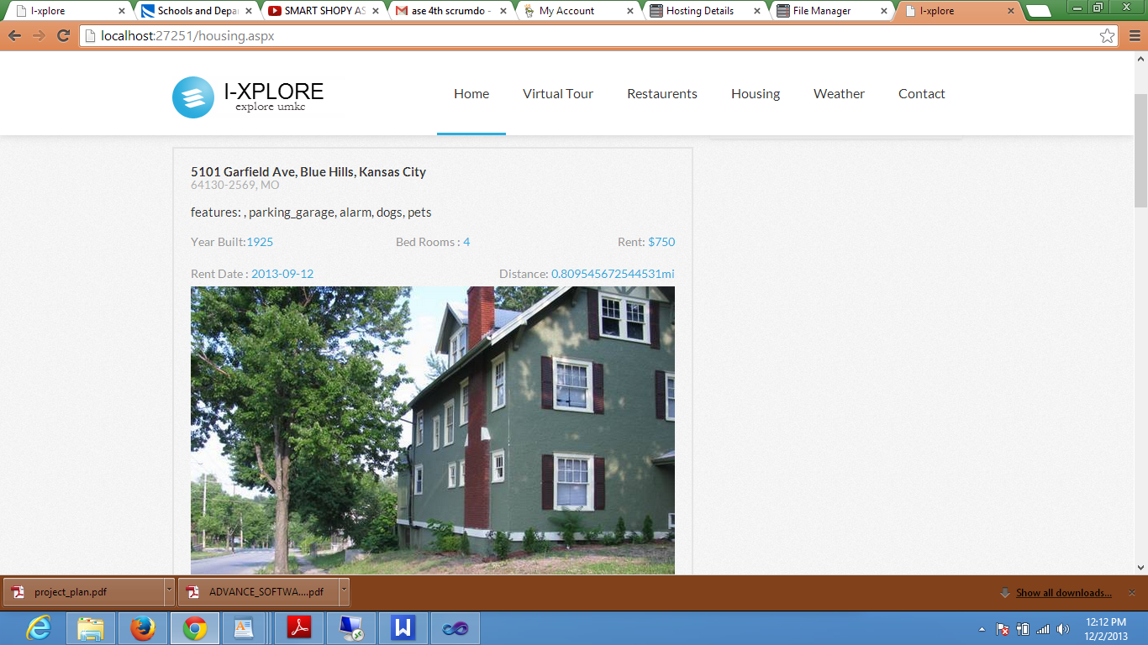

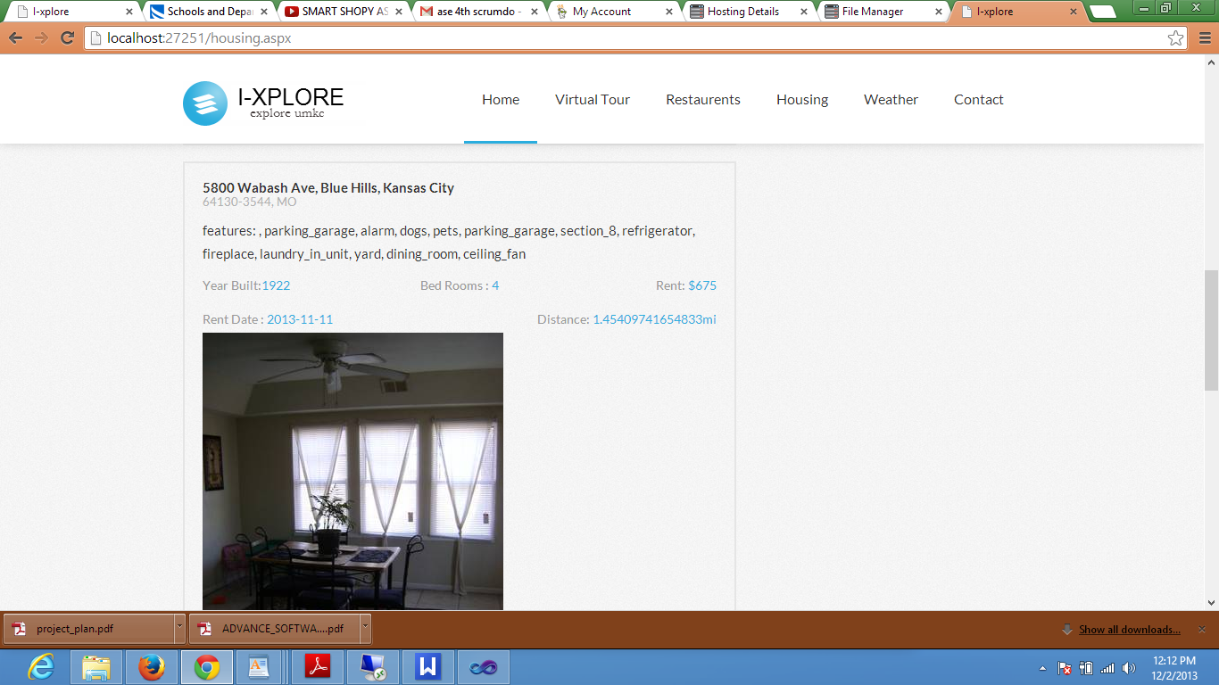

Contact us feature in web application which provides contact information of various departments in UMKC.

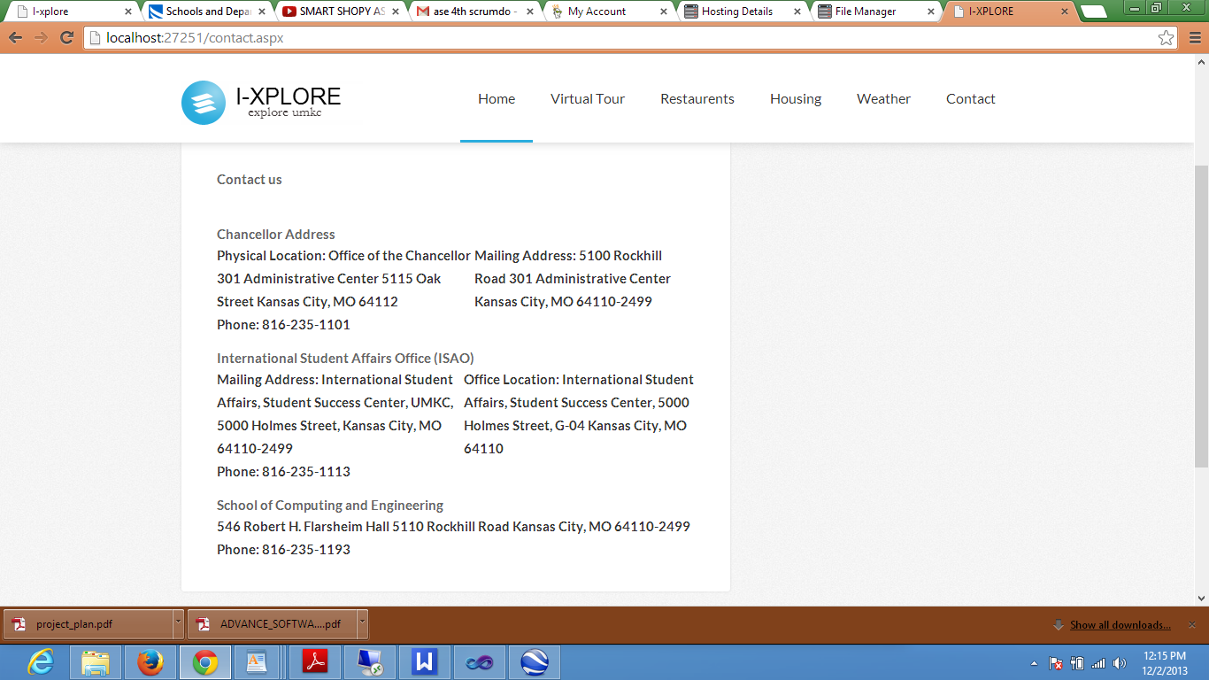

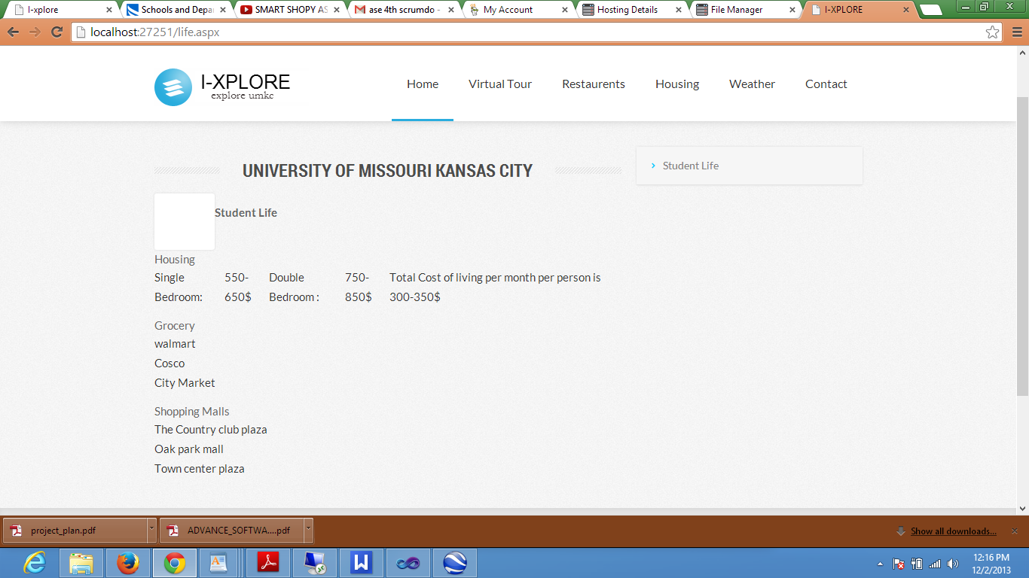

**Creating stories to Iteration-4:**

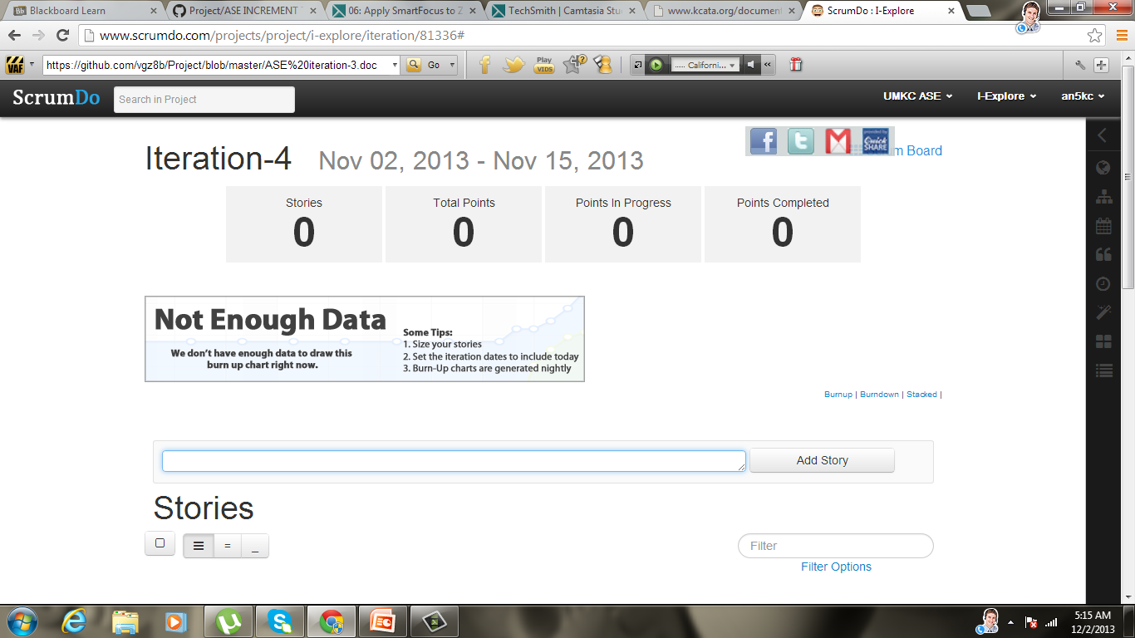

Development of nearby housing application is assigned to one of the team member vgz8b. This application provides information regarding housing options nearby university to the users.

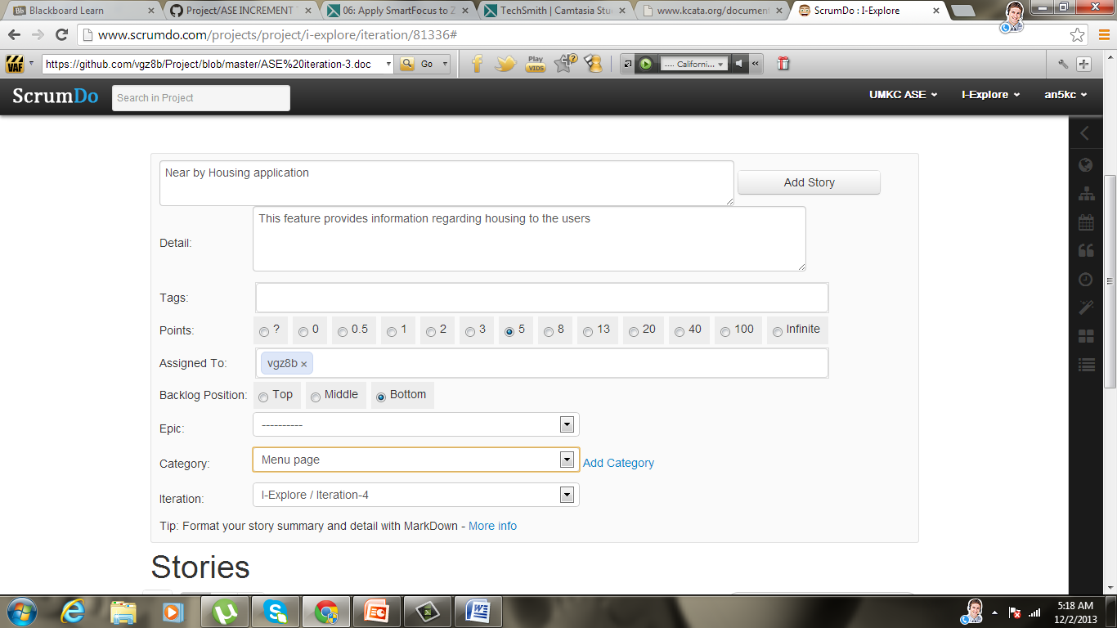

Development of another feature student life is assigned to another member of the team (an5kc). This feature provides useful information regarding cost of living, entertainment near the university, restaurants ext.

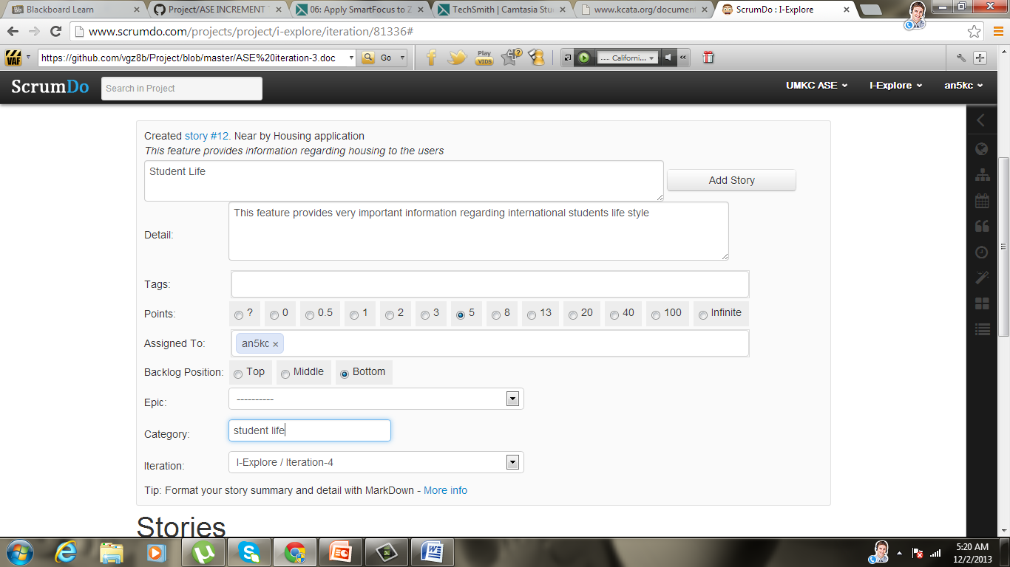

Tend to Admissions application development is done one more member of team (naveen96). This application provides information to the users that whether they can get admission into UMKC or not.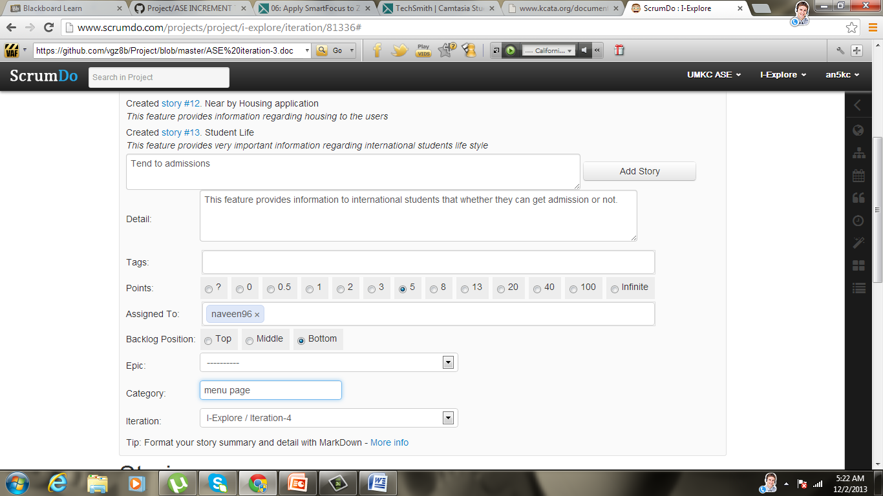

Another feature contact us is developed by another member of team (arishanker1). This feature provides contact information of various departments of UMKC.

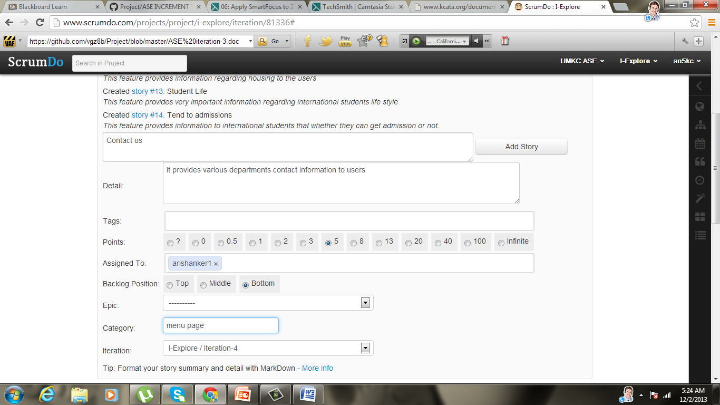

Designing feature development is assigned to two members of the team. In this we developed designing part of web application.

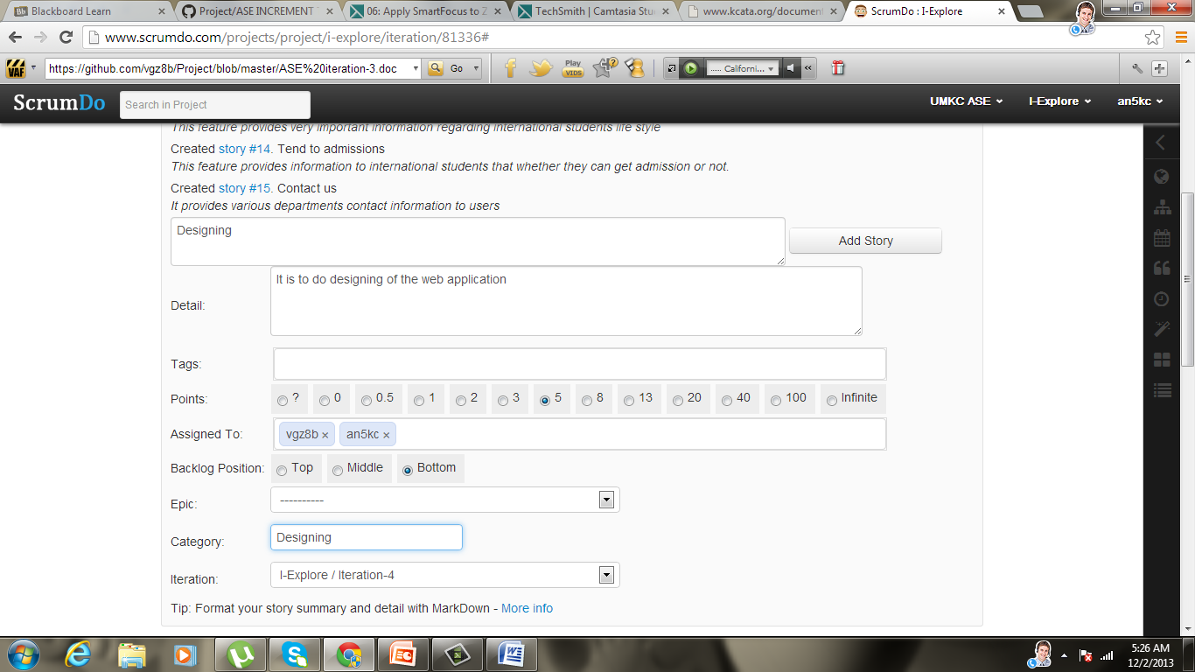

Below screen shot shows that iteration-4 has 5 stories and total of 25 points.

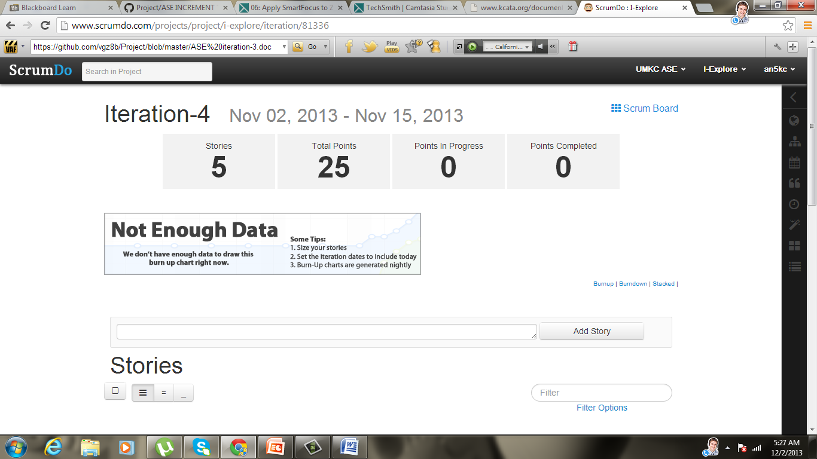

Representing stories.

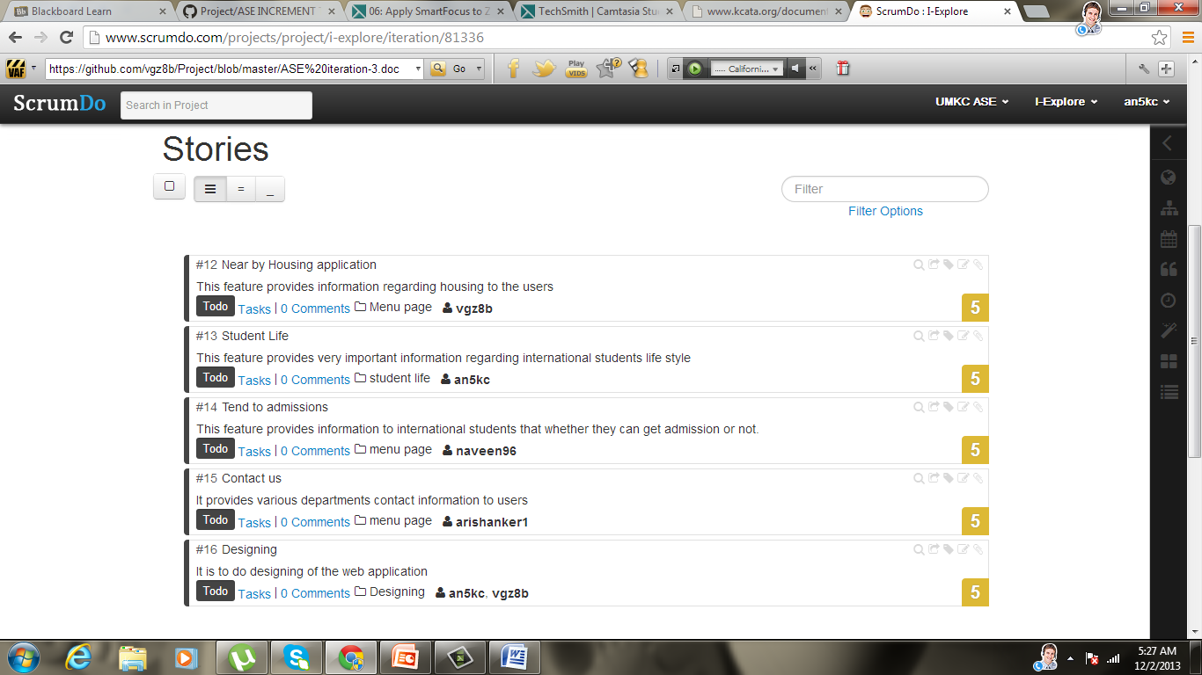

In order to see status of stories go to project click on scrumdo.

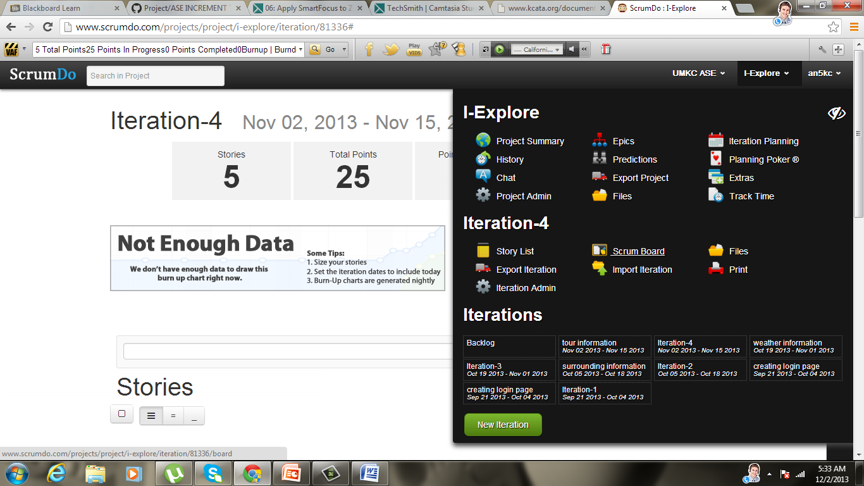

Before doing the tasks status of stories is ToDo

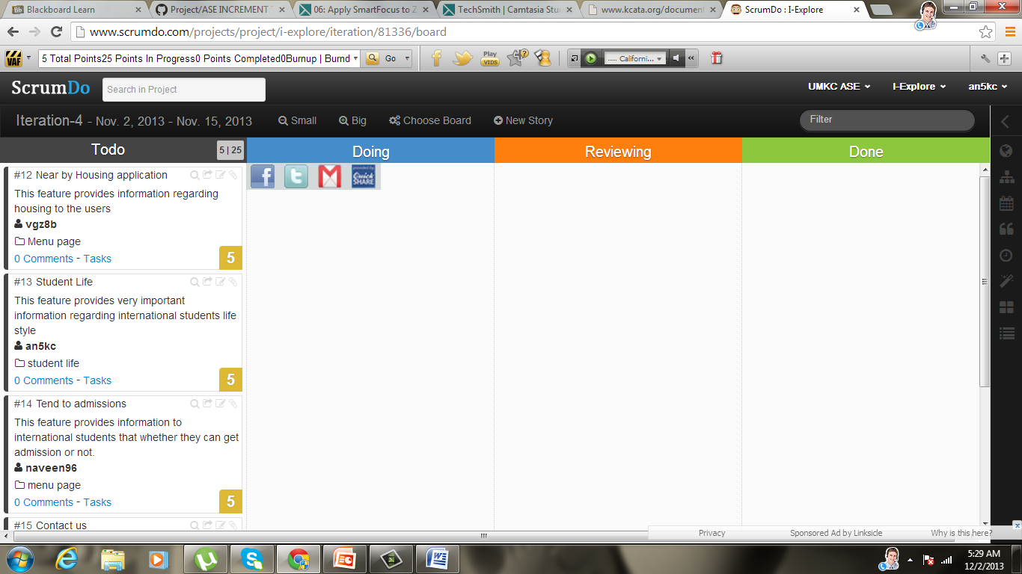

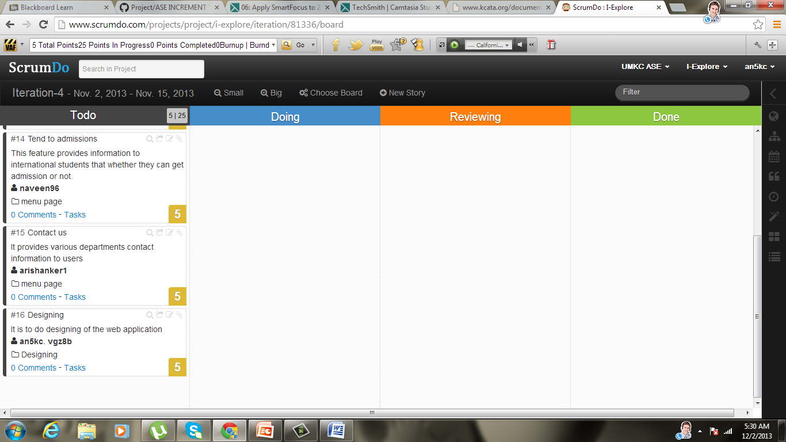

After completing the tasks the status of stories changed to Done.

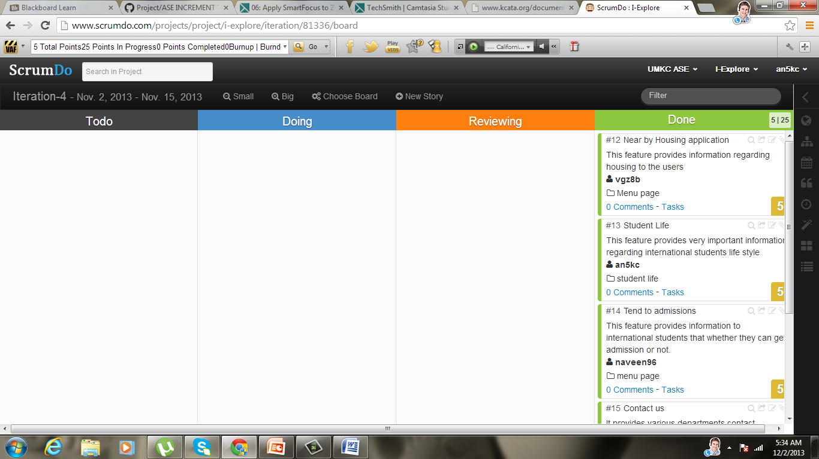

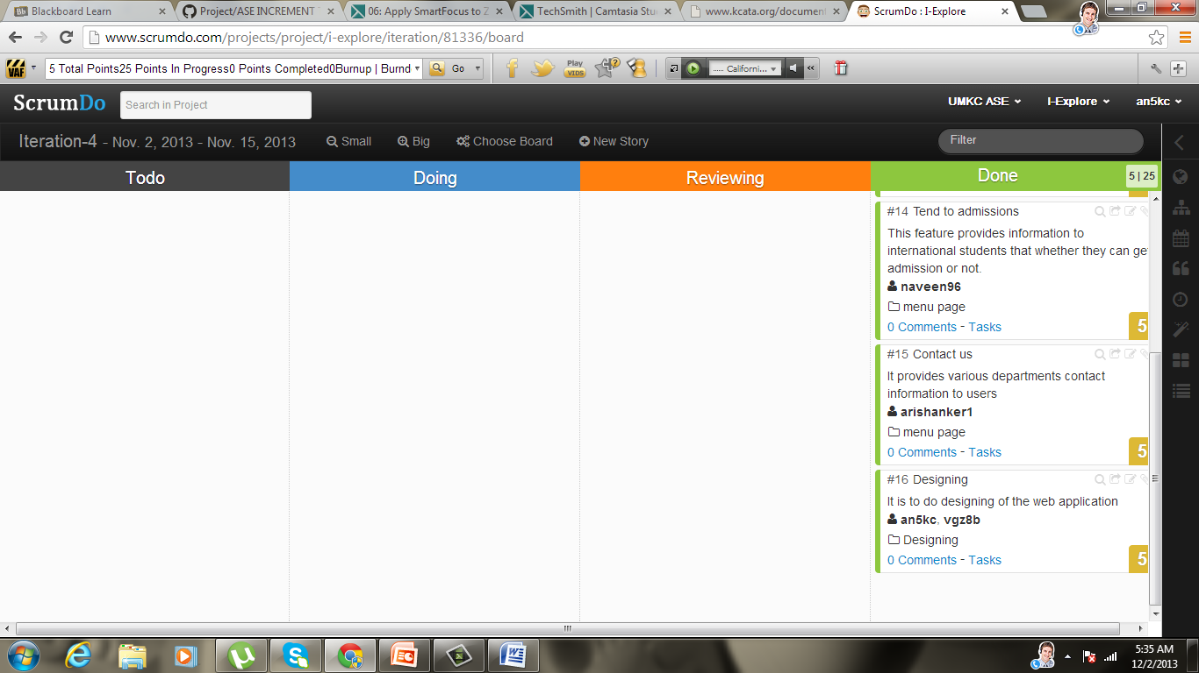

**Project Management:**

Member:

VISHNU PRAVEEN GUDE:

Designing

Housing.

RAVI SANKAR ARE:

Contact us

VENKATA NAVEEN PANDALA:

Tend to admissions

AYYAPPA KUMAR NEERUKONDA:

Designing

Student Life